1. **Agenda**:
   1. We will implement use case for “**Adapter Pattern**”
2. 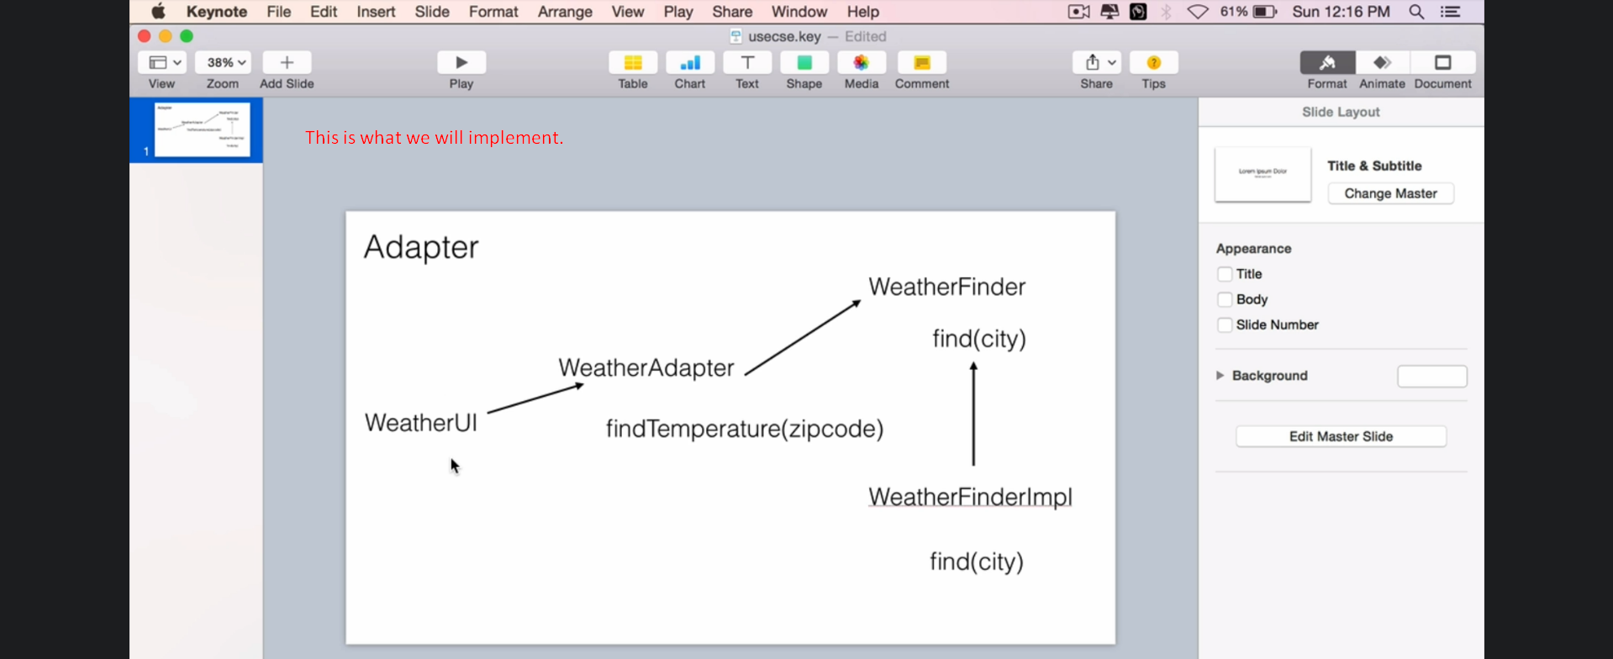
3. Let’s start implementing “Adapter Pattern”.
4. 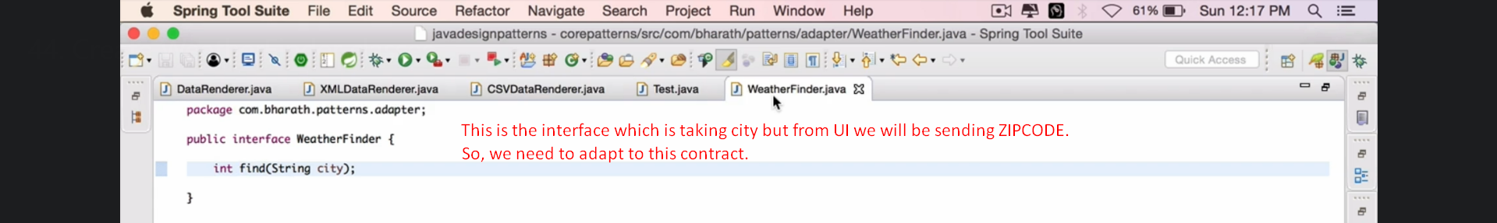
5. 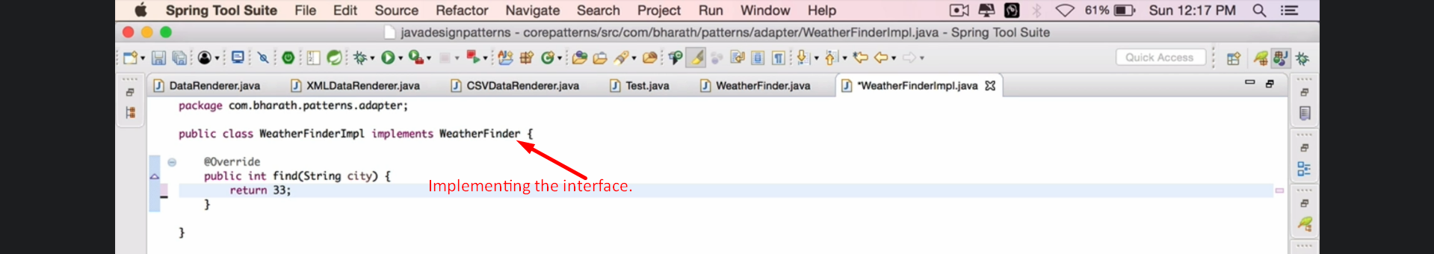
6. 